**LABORATORY EXPERIMENT 1:**

**MATERIAL TENSILE TESTING REPORT**

**Henri Tuoma** **549707**

**Jonathan Lundström,** **708593**

**Markus Forsback 493905**

**Binh Nguyen** **887799**

**Topi Laitinen 100603611**

**Symbols**

|  |  |  |
| --- | --- | --- |
| **Symbol** | **Unit** | **Designation** |
| b0 | (mm) | Original width |
| a0 | (mm) | Original thickness |
| Lc | (mm) | Parallel length |
| S0 | (mm2) | Original cross-sectional area |
| Lu | (mm) | Final Gauge length |
| L0 | (mm) | Original gauge length |
| vc | (mm/min) | Crosshead separation rate |
| é | (1/mm) | Strain rate |
| σ | (MPa) | Stress |
| e | (mm) | Strain |
|  | % | Percentage elongation after fracture |
|  | (GPa) | Young’s modulus |

**1. Introduction**

In this report, a tensile test is conducted in the material testing laboratory by a group of students from the Materials Safety course. The goal of this report is to describe how the tensile test was conducted and what information was measured. Additionally, this laboratory exercise also clarifies and deepens the knowledge about materials properties, such as elasticity, plasticity, stiffness, strength, and ductility. Before the test, instructions for the laboratory were given based on ISO 6892-1:2016 A224 metallic materials standard to help students familiarize themselves with the standardized methods for conducting the test. It was recommended that the specifications of the tensile test should be studied before the laboratory, such as what can be measured by the test, and what can be utilized, for example. At the laboratory, all the group members were present. At the beginning, a short introduction from the course assistant and laboratory personnel was delivered, after which the test was conducted according to the instructions and standards provided in advance. The tasks were to carry out tensile tests for two different metallic test samples, whose detailed material properties were not given besides that other of the samples had a coating. Because there were multiple people and the working space was limited, the first and second tests were completed by different group members. The data, such as dimensions of the test samples and test results, were documented by different students in their notebooks and Excel, in addition to the videos and pictures taken by phones of the students from different phases of the test.

Tensile test is used for measuring material’s ability to resist the tension force, which is applied to the test specimen by connecting it to a tensile testing machine, which in this case was MTS Insight Electromechanical – 30kN Standard length tensile testing machine. The dimensions of the test specimen are set to the machine, in addition to the cross-head separation rates calculated according to the standard. The tensile test machine gives stress-strain curve, from which different kinds of information from the material can be interpreted, such as elastic modulus, yield strength, tensile strength and fracture point. These values describe how much the material elongates with certain amount of stress, how much stress is needed to deform the material permanently, what is the maximum amount of stress the specimen can resist and the point when the specimen fractures. These characteristics of the material are important to know, for example when estimating, how much load a certain structure can hold safely.

Tensile testing is of crucial importance to understanding the materials in operations. For example, in the automotive industry, the material can be preprocessed by a Marciniak test punch in different prestraining states, such as uniaxial, biaxial or plane strain stress state. After that, uniaxial testing can be carried out in different angle directions, such as rolling and transverse directions to measure how the material behaves in different loading conditions. Additionally, by having the experimental force-displacement data from tensile testing, we can use it as validation data to calibrate many material models, such as plasticity model and fracture models. Simulations by computational softwares can further derive other expected material properties based on the calibrated model from tensile testing.

**2. Methods**

Two pieces of unidentified metals, seen in figure 1, were tested following the SFS-EN 6892-1 *Metallic materials* standard, method A. Some advice and instructions from lab personnel were also followed during the testing, these are separately mentioned in the report.

Figure 1 The two specimens after tensile test, one on top and second under, with gauge length marked.

Prior to conducting the tensile tests, the dimensions of the specimens were measured using a caliper and a plastic ruler. The widths and thicknesses of the specimens were measured with the caliper at three points on the tapered parts of the specimens, close to the middle and near both ends. The gauge length was marked on the specimen with a marker and measured with the ruler to be 50 mm, as is said in the standard’s annex B and shown in figure 2. Also, the parallel lengths were measured with the ruler. Measurements are presented in table1, the original cross-sectional areas were calculated from each measurement and then an average of each value was calculated for the specimens.

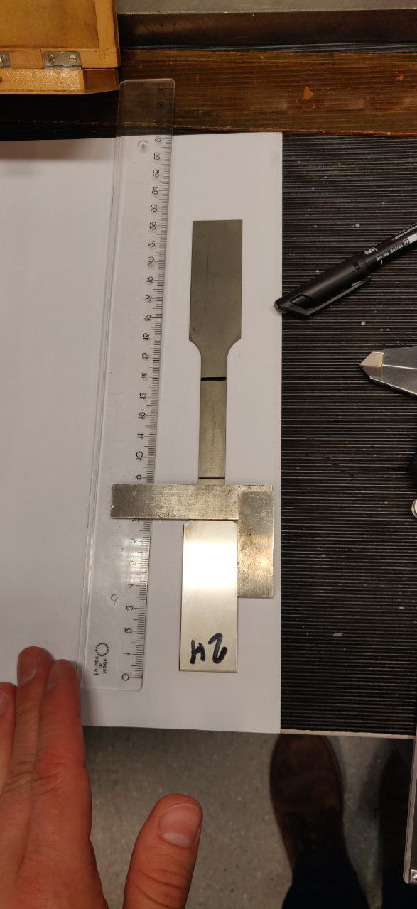

Figure 2 Marking the gauge length on specimen one, using the ruler and a square.

Table 1 Measurement data for the specimens.

|  |  |  |  |
| --- | --- | --- | --- |
| **Sample 1** | **Measurement 1** | **Measurement 2** | **Measurement 3** |
| Original width, b0 (mm) | 12,47 | 12,5 | 12,5 |
| Original thickness, a0 (mm) | 1,01 | 1,02 | 1,02 |
| Original gauge length, L0 (mm) | 50 |  |  |
| Parallel length, Lc (mm) | 75 |  |  |
| Original cross-sectional area, S0 (mm2) | 12,595 | 12,75 | 12,75 |
| Final gauge length, Lu (mm) | 68 |  |  |
|  |  |  |  |
| **Sample 2** | 1 | 2 | 3 |
| Original width, b0 (mm) | 12,55 | 12,53 | 12,54 |
| Original thickness, a0 (mm) | 0,92 | 0,91 | 0,92 |
| Original gauge length, L0 (mm) | 50 |  |  |
| Parallel length, Lc (mm) | 75 |  |  |
| Original cross-sectional area, S0 (mm2) | 11,546 | 11,4023 | 11,5368 |
| Final gauge length, Lu (mm) | 50 |  |  |

To perform the tensile tests according to method A in the SFS-EN ISO 6892-1 standard, two crosshead separation rates, vc, were calculated, for range 2 and range 3. However, the lab personnel advised to use other values instead of the calculated ones, all values are shown in table 2. The advised values for both ranges are well inside the relative tolerance of ± 20 %, mentioned in the ISO 6892-1 standard.

Table 2 Calculated and advised values for crosshead separation rates.

|  |  |  |
| --- | --- | --- |
|  | **Range 2 (mm/min)** | **Range 3 (mm/min)** |
| **vc calculated (vc= Lc* é*60s)** | 1,125 | 9 |
| **Lab personnel’s value** | 1 | 10 |

For the tensile tests, the data is collected using the MTS Insight Electromechanical – 30kN Standard length tensile testing machine together with MTS extensometer, as can be seen in figure 3. The specimens were firmly mounted within the testing machine’s grips on their turn, with meticulous attention to proper alignment and grip adjustment as per the ISO 6892-1:2016 standard. Also, the extensometer was carefully installed on the tapered part of the specimens. Both specimens went through the same testing cycle, with the only difference that the first test was paused by the computer to remove the extensometer when the yield strength was reached. In the second test cycle, the test was paused manually based on the data and graph provided by the machine, lab personnel advised when the yield strength was reached, and it was time to pause the test. After pausing and removing the extensometer, both tests continued with the crosshead separation rate of range 3 until the specimens fractured.

**Why do we need to remove the extensometer**: As the specimen undergoes further deformation and approaches its point of fracture, the rapid and significant deformation can damage the extensometer. Removing it ensures that the device is not damaged or subjected to forces beyond its design limits. From page 42 in the ISO6892, if the extensometer is removed or if the extension measurement is interrupted before fracture but after maximum force, then we can use crosshead displacement to determine the additional elongation between removal of the extensometer and fracture point.

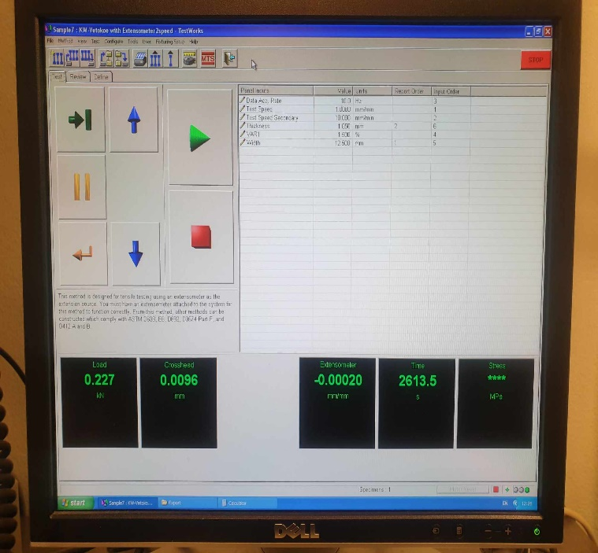

Figure 3 Tensile testing rig, with the specimen and extensometer attached.

After the tests, both specimens were measured for their final gauge lengths, presented in table 1. All data from the tests were obtained from the testing machine’s computer as raw data in text files. For analyzing the data, it was visualized by using Microsoft Excel.

**3. Results**

**3.1 Results of sample 1**

*Figure 4. The final gauge length of the test sample 1 was 68mm, therefore the elongation was 68mm-50mm=18mm.*

This is the original Force-extension curve of speciment 2 measured in the tensile test:

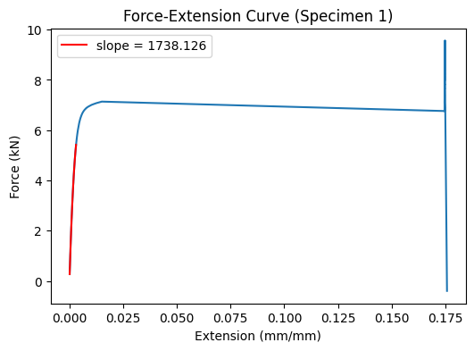

Figure 5: The Force-Extension curve of specimen 1

Figure 4 6: Engineering stress-strain for extensometer data for sample 1.

First, we calculate Young’s modulus for both materials. Youngs modulus is obtained through equation (1). And taking the values σ and 𝜀 from the linear elastic part of the curve.

(1)

Based on figure 1. Young's modulus can be estimated to be around 197.0 GPa. Youngs modulus for steel is around 190-215 GPa. This means that the first material is likely to be some sort of steel. The measurement is rounded to the nearest 0,1 GPa and according to ISO 80000-1

Secondly, we calculated the yield strengths of the materials. The yield strength is hard to determine since we do not know the exact point at which the material starts behaving nonlinearly. However, we can estimate it using linear trend line tool in excel and using extension 0.2% offset line method. This method is often used to estimate yield strength of a material from a stress-strain curve. Using extension 0.2% offset line method we add 0.002 into yield strain values and calculate new values for yield stress through this strain.

The extension 0.2% offset line is obtained through equations (2) and (3)

(2)

(3)

Using these equations, we obtained 0.2% offset strain-stress data. This data can be used to create a line that estimates at which point the material starts to behave nonlinearly. Plotting the data into figure 1 gives us the line colored as black. The point at which the line crosses the stress-strain curve is around 490 MPa. This method indicates that 490 MPa is the yield strength of this material.

Figure 5 7: Engineering stress-elongation for sample 1.

Thirdly, we calculated percentage elongation after fracture. This can be calculated by using the equation from the ISO standard which is.

(4)

Plugging the values for Lu and Lo gives us roughly A = 36% after fracture elongation for the first material.

Finally, we calculated the tensile strengths of the materials. For the first material the tensile strength can be estimated from figure 2. The point at which the black line crosses the stress-strain curve is the tensile strength of the material. This is around 752 MPa.

**3.2 Results of sample 2**

Figure 8. Total elongation after fracture, sample 2

The final gauge length for sample 2 was 50mm, with no elongation. As can be seen from figure 9, the fracture occurred outside of the gauge length area. The elongation after fracture was not therefore measured because the elongation was significantly smaller compared to sample 1.

This is the original Force-extension curve of speciment 2 measured in the tensile test:

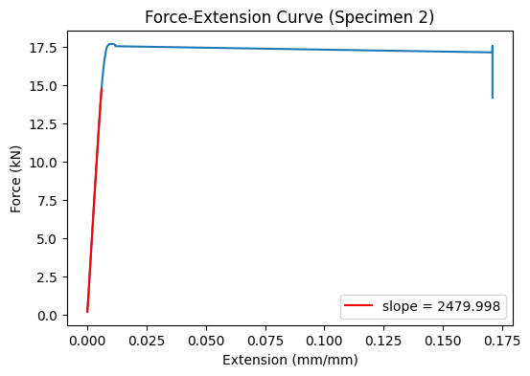

Figure 9: The Force-Extension curve of specimen 2

Figure 7 10: Engineering stress-strain curve for sample 2.

Using similar equations as provided in explanation for sample 1. For the second material the Young’s modulus can be estimated to be around 220 GPa.

Yield strength was obtained similarly. The point at which the line crosses the stress-strain curve is around 1540 MPa. This is the estimated yield strength of the material.

Figure 8 11: Engineering stress-elongation for sample 2.

For the second material fracture elongation was A = 0%. A plausible explanation is that the first material is very ductile, so it experiences noticeable degree of strain, while the latter is very brittle, which underwent very little elongation before fracture, as seen from figure 10. This is discussed further in the discussion section.

For the second material the line crosses in figure 4. The point at which the black line crosses the stress-strain curve is around 1540 MPa. The ultimate tensile strength of the material is then around 1540 MPa. This means that the tensile strength is the same as the yield strength for the second sample material.

**3.3 Both samples fracture location**

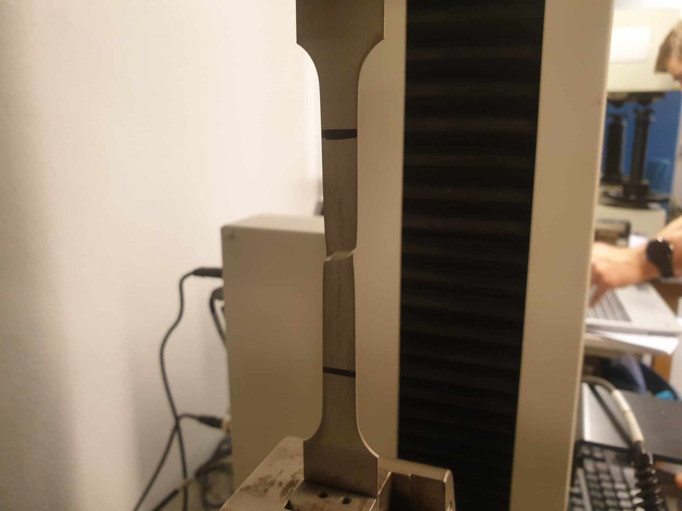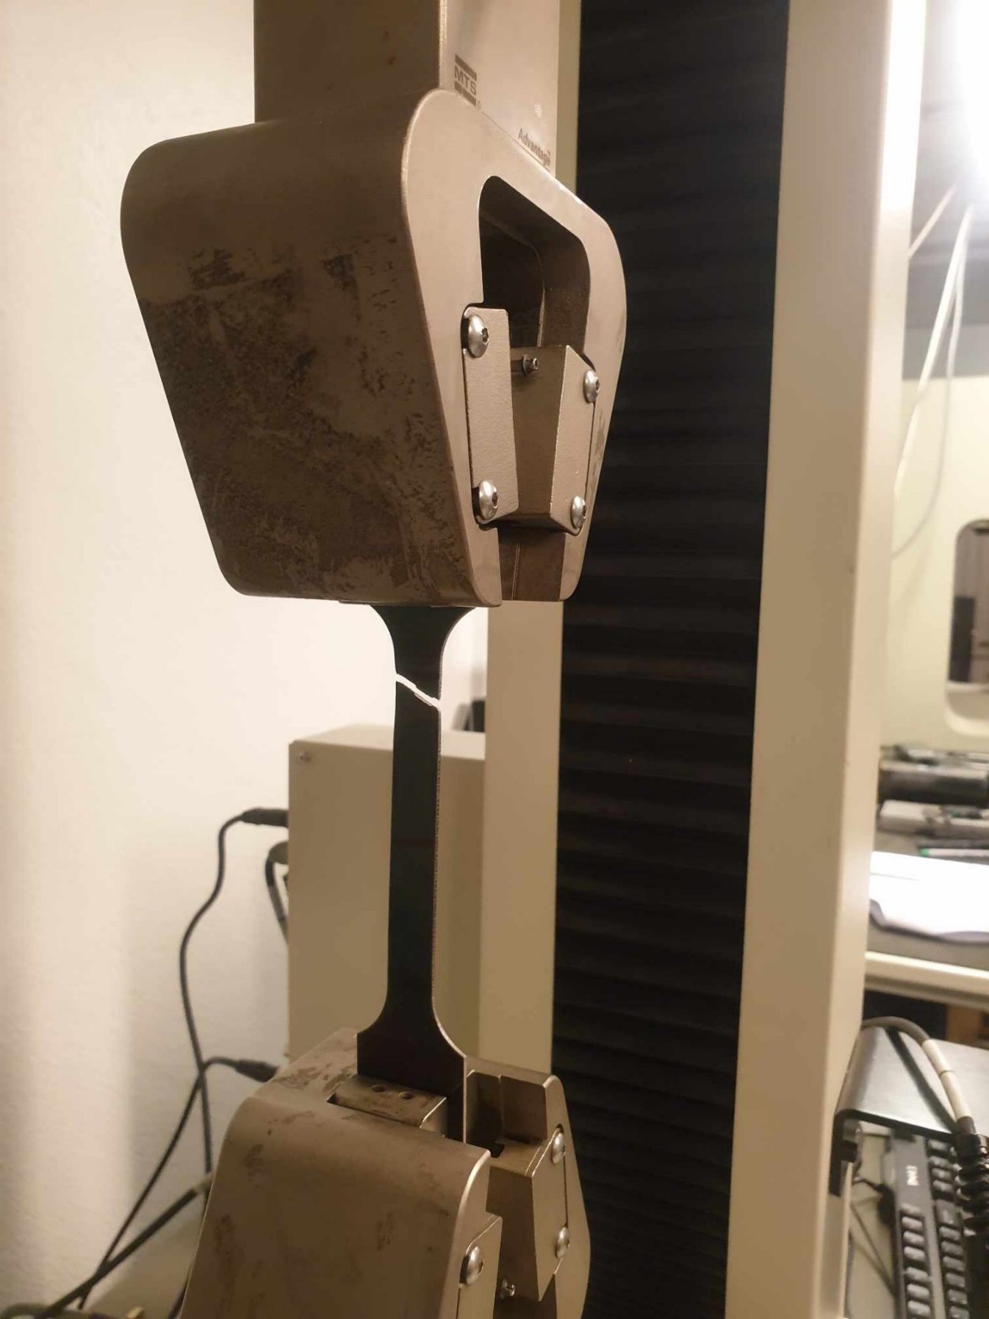

*Figure 12: The specimen 1 (left) and 2 (right) fractured after a significant force is applied.*

We can see from figure 12 that there is a noticeable necking region around the fracture location in specimen 1, whose middle gauge is thinning in width. On the other hand, the 2nd specimen does not have any necking, and the fracture surface has a clean cut.

**4. Discussion**

**Reasons why the fracture of two specimens occurred at** **different locations:**

The point of maximum stress is generally where the fracture will initiate. If there are any imperfections, notches, or inclusions in the material, they can act as stress concentrators. In other words, strain is localized on that region, which decides the fracture location. Given that the material is unknown, we can only rely on the specimen geometry, testing conditions and results.

Regarding geometry: Both specimens have almost equal original cross-sectional area and thickness, suggesting that geometry should not be the reason why they fracture differently.

Regarding testing conditions: The main difference between the two tests is the method of pausing the test to remove the extensometer. In the first test, it was computer-controlled, ensuring a precise and consistent point of pausing based on the yield strength. In contrast, the second test relied on manual observation, which introduces a level of subjectivity and potential variability. This difference in pausing might influence the stress distribution during the test. Even slight variations in the timing can lead to different stress-strain histories, which can influence the fracture location.

Regarding testing results: Specimen 1’s ultimate strength is 750 and maximum displacement is 27mm, while specimen 2’s ultimate strength is 1540 MPa and maximum displacement is 4.8mm. The lower ultimate strength and higher displacement of specimen 1 suggest that it is very ductile, which tends to neck or reduce in cross-sectional area at the point of maximum stress, which is typically around the middle of the gauge length. In other words, Specimen 1 is able to distribute stress evenly.

The lack of significant elongation in Specimen 2 indicates that it could not redistribute stresses as effectively as Specimen 1. This means that any stress concentrators, imperfections, or high-stress regions would have a more noticeable effect. The fracture location being above the middle of the gauge in Specimen 2 suggests that there might have been a stress concentrator or a region of higher stress in that area. However, the suspected defects cannot be confirmed since additional tests should be conducted to study the microscopy, such as fractography or SEM analysis.

**Measurement uncertainty:**

The estimation of the measurement uncertainty can be based on absolute values or relative estimations. In the manual, the estimation according to CWA 15261–2 is based on absolute values, which results in different estimations of the respective single uncertainty budgets if, for example, the test piece dimensions, or the extensometer gauge length differs. On the other hand, the estimation according to Annex K is based on relative estimations. Additionally, the test conditions and limits defined in the ISO 6892-1 standard should not be adjusted to account for uncertainties of measurement.

An absolute uncertainty is expressed in the same unit of measurement as its associated result. A relative uncertainty is expressed in a term relative to its associated measurement result. In this report, since the test piece dimensions differ slightly by an order of 0.01mm, it is recommended to use absolute uncertainty to measure the error of the Young’s modulus.

The measurement uncertainty according to CWA 15261-2 is

(5)  
where

, is the extensometer gauge length;

, is the original cross-sectional area;

, is the slope of the force-extension curve;

, is the uncertainty of extensometer gauge length;

, is the uncertainty of original cross-sectional area;

, is the uncertainty of slope of the force-extension curve.

The measurements that we have recorded are as follows

= 50mm = 12.595 mm2 = 197.969 kN/mm

= 0.01 mm = 0.155 mm2 = 0.05kN/mm (based on regression errors)

Plugged into the formula above, the absolute error is 86.4 GPa in its Young’s modulus, which is a significantly large error. There could be some errors in dimensions calculations, or the estimated uncertainty is not precise. Doing the same task for specimen two, we have its absolute error as 134.65 GPa in its Young’s modulus, which is again too large uncertainty. We hope that the measurement uncertainty can be re-evaluated more carefully if provided another tensile testing’s opportunity.

**Materials of the samples**

Both specimens were of unknown material, however both were metals. Based on visual inspection of the specimens, but mostly on the obtained values for their yield strength, tensile strength and elongation in the tensile tests, some possible candidates were found. Granta Edupack material database was used, and different metals were plotted with respect to the above-mentioned values. The first specimen had similar properties to Duplex stainless steel or Inconel alloys such as Inconel 601. The second specimen was very brittle and had a very high tensile strength together with short elongation, it is likely to be some martensitic steel. A slightly yellow colored surface on the second specimen indicates that it could be an alloy containing copper.

**Brief conclusion:**

This laboratory exercise has taught students the skills to:

* Read standard manuals in mechanical testing, such as ISO 6892
* Learn to use the equipment in tensile testing, such as the extensometer, the tensile testing machine and the software specifications
* Learn how to record data and present scientific formulas to derive materials’ properties
* Learn how to interpret the results and correlate them with the observations.

This report summarizes the knowledge the students have gained, and it can be used as a reference so others can replicate similar experiments in the future.